Work Experience Insights Programme

Expressions of Interest - Guidance and Tips
Organisational Development, October 2026

This guidance is targeted at students, with the support of their guardians and school/college, with their application for the upcoming Work Experience Insights Programme.

Contents

Introduction 2
Programme and Process Overview 3
Key Process Dates: 3
Application Completion Guidance 3
Additional Hints and Tips to help with your application: 5
Additional Support and Information 6

Introduction
Thank you for your interest in our upcoming Work Experience Insights Programme! This guidance has been created to support you with the application, giving you information, hints and tips to make sure that you put forward the best application and get to showcase why you are a suitable delegate for the programme.

Programme and Process Overview
The programme will see 36 participants visit over 2 x 1-week periods (72 in total) within the summer. One week (36 participants) will be dedicated to school age children; year 10 and year 11 students. The other week will be dedicated to collage age students (year 12 and 13 students). The dates for hosting students in 2027 are as follows:

College Week (Year 12 and 13 Students)
Monday 14th June – Friday 18th June 2027

School Week (Year 10 and 11 Students)
Monday 28th June – Friday 2nd July 2027

Unfortunately, we are unable to offer places to everyone who applies. Applications will be reviewed through a fair and robust selection process, and places will be offered based on the information provided in the application form. We are also unable to offer any Work Experience opportunities outside of this programme.

This supporting guidance should be able to assist with your application, accessible here.

Key Process Dates:

Application Completion Guidance

1. Administrative and Information Section
The first section will request administrative information to including your name, date of birth, school/college information and emergency contact details. Any student under 18 will also require parent/guardian consent to process the application, so information of this will also need to be provided.

Please ensure that all information is correct as this will be how we will contact you for application updates, and these details will be used during the Work Experience Insights week in case of emergency. Should there be any changes needed after you submit the application, up to and including the placement week, please ensure you let us know via email, as soon as possible:
WorkExperience@staffordshire.police.uk

An example application to show this administrative section is below:
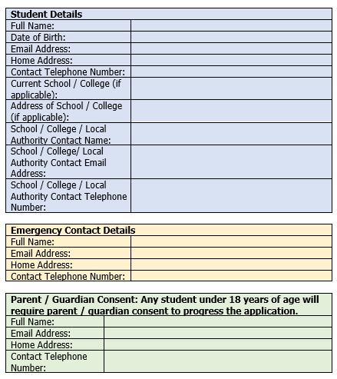

2. Personal Statement Section
The final section of the application is all about you as the student! This is the part where the sifting panel gets to learn all about you, your interests and why you are applying.

This section is marked by the sifting panel to see whether you are suitable for the programme and will be scored across four key areas that we have deemed as essential for delegates. Whilst we are unable to share specifics as to what these areas are to ensure a fair process; examples of things that could be included in this are:
- Your interests
- What exams and subjects you are taking or interested in taking at School/College
- Why you are applying to the programme
- Why Staffordshire Police is of interest
- What you are passionate about
- Do you do anything outside of School/College that you are passionate about or assist you with gaining skills
- Whether you have a career goal or pathway in mind for the future

With previous applications, we’ve found the more detail and information you provide that shows your passion and enthusiasm for the programme, policing or Staffordshire Police the better!!

An example application to show this personal statement section is below:
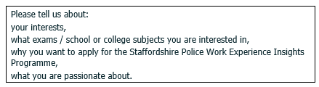

Additional Hints and Tips to help with your application:

1) Before you start filling out the application form, carefully read all the instructions provided. Ensure you understand what is required for each section of the form.

2) Provide accurate and up to date personal information (name, address, phone numbers etc.)

3) All sections of the application form need to be completed.

4) The mandatory fields are marked with an asterisk * beside them. These fields must be completed before you can submit the application form.

5) Make sure that your personal statement is reflective of you, your skills, passions, interests and achievements as this will help to demonstrate to the sifting panel that you are a suitable candidate and marks will reflect this.

6) If a page asks for large amounts of information, the data fields may be larger than the width of the page. If this is the case, use the scroll bar at the bottom of the page to scroll across to the right, and the missing mandatory field will appear.

7) Carefully review your completed application form for any errors or spelling and grammar mistakes. Consider asking a friend or relative to review it as well.

8) Ensure you meet the application deadline! We are unfortunately unable to accept any applications after this time.

Additional Support and Information

Should you have any further questions or queries, we have an FAQ section on our website that may be able to assist. This can be found here: Work Experience Insights Programme | Staffordshire Police

In addition to this, there is our Work Experience Insights Programme Guidance which is accessible here.

If you have looked at the above and still have questions, or need to update administrative details following application submission, please contact our dedicated email: workexperience@staffordshire.police.uk

Again, thank you for your interest in Staffordshire Police's Work Experience Insights Programme! We look forward to receiving your application soon!

